Assignment - Python [Major]

10-07-23

1. Find the datatype of these two declaration : x = 5

y = "John"

Ans.

x = 5

y = "John"

x_type=type(x)

y_type=type(y)

print(f"Data type of 'x' is {x_type} and 'y' is {y_type}")

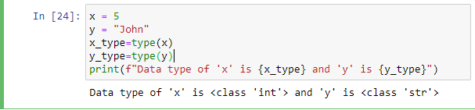

1. Check whether the following syntax is valid or invalid for naming a variable. :

Example: abc=100 valid syntax

i. 3a=10

Ans. #valid syntax

* 1. @abc=10

Ans. #Invalid syntax

* 1. a100=100

Ans. #valid syntax

iv. _a984_=100

Ans. #valid syntax

v. a9967$=100

Ans. #Invalid syntax

vi. xyz-2=100

Ans. #Invalid syntax

1. Check if element exists in list in Python : list = test_list = [1, 6, 3, 5, 3, 4]
2. Check if 3 exist or not.

Ans.

list = test_list = [1,6,3,5,3,4]

if 3 in test_list:

print(f"Yes 3 exists in the list")

else:

print(f"No, 3 doesn't exist in list.")

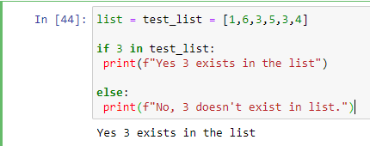

1. Check if 9 exists or not.

Ans.

list = test_list = [1,6,3,5,3,4]

if 9 in test_list:

print(f"Yes 9 exists in the list")

else:

print(f"No, 9 doesn't exist in list.")

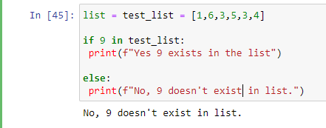

1. Take the user input to print the current date.

Ans.

import datetime

user_input=input("Enter the current date in dd-mm-yyyy format:")

now= datetime.datetime.now()

print("user input:", user_input)

print("Current time:", now.strftime("%d/%b/%Y"))

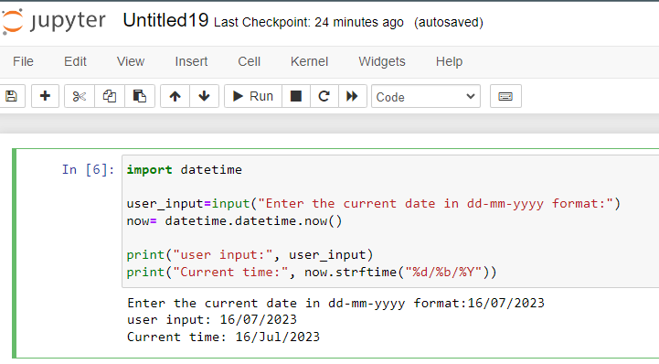

1. what is the output of the following code :
2. print 9//2

Ans.SyntaxError,

due to absence of ‘()’ brackets.

If corrected the response would be 4.

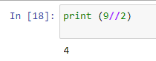

1. print 9%2

Ans.SyntaxError,

due to absence of ‘()’ brackets.

If corrected the response would be 1 which is remainder in above division.

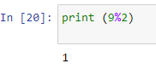

1. Print First 10 natural numbers using a while loop.

Ans.

i=1

while i<11:

print(i)

i=i+1

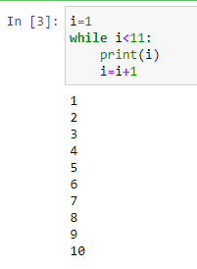

1. Write a program to accept a number from a user and calculate the sum of all numbers from 1 to a given number.

For example, if the user entered 10 the output should be 55 (1+2+3+4+5+6+7+8+9+10)

Ans.

user_input = int(input("Enter a number: "))

i = 1

total = 0

while i <= user_input:

total += i

i += 1

print("The sum of numbers from 1 to", user_input, "is:", total)

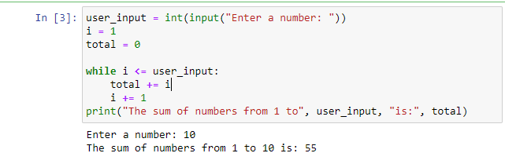

1. Write a Python program which iterates the integers from 1 to 50. For multiples of three print "Fizz" instead of the number and for the multiples of ﬁve print "Buzz". For numbers which are multiples of both three and ﬁve print "FizzBuzz".

Example :

ﬁzzbuzz 1

2

ﬁzz 4

buzz

Ans.

for i in range(1,51):

if i % 3== 0 and i % 5== 0:

print("FizzBuzz")

elif i % 3 == 0:

print("Fizz")

elif i % 5 == 0:

print("Buzz")

else:

print(i)

